**Tutorial 4**

**1.** Define each of the following terms: a. determinant

b. functional dependency

c. transitive dependency

d. recursive foreign key

e. normalization

f. composite key

g. relation

h. normal form

i. partial functional dependency j. enterprise key

**2.** Match the following terms to the appropriate definition

1. well-structured relation

2. anomaly

3. functional

dependency

4. determinant

5. composite key 6. 1NF

7. 2NF

8. 3NF

9. recursive foreign key

10.relation

11.transitive

dependency

a. constraint between two attributes

b. functional dependency between the primary key and a nonkey attribute via another nonkey attribute

c. references the primary key in the same relation d. multivalued attributes removed

e. inconsistency or error

f. contains little redundancy

g. contains two (or more) attributes

h. contains no partial functional dependencies i. transitive dependencies eliminated

j. attribute on left side of functional dependency k. named two-dimensional table of data

**3.** Describe how the following components of an E-R diagram are transformed into relations:

a. regular entity type

b. relationship (1:M)

c. relationship (M:N)

d. supertype/subtype

e. multivalued attribute

f. weak entity

g. composite attribute

h. derived attribute

**4.** The figure shows a class list for Millennium College. Convert this user view to a set of 3NF relations using an enterprise key. Draw an EER. Assume the following:

• An instructor has a unique location.

• A student has a unique major.

• A course has a unique title.



**5.** Given a piece of data, state the dependencies and draw an EER: 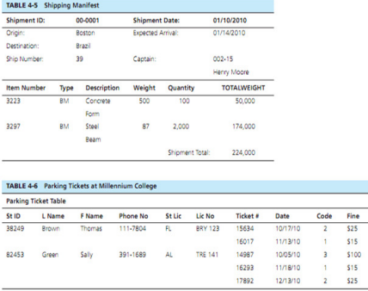

**6.** The materials manager at Pine Valley Furniture Company maintains a list of suppliers for each of the material items purchased by the company from outside vendors. Table 4-7 shows the essential data required for this application.

a. Draw a dependency diagram for this data. You may assume the 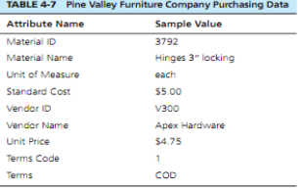 following:

• Each material item has one or more suppliers. Each supplier may supply one or more items or may not supply any items.

• The unit price for a material item may vary from one vendor to another. • The terms code uniquely identifies the terms of the sale (e.g., code 2 means 10 percent net 30 days, etc. At a given time, a supplier applies a term code. The terms for a supplier are the same for all material items ordered from that supplier.

b. Decompose this diagram into a set of diagrams in 3NF.

c. Draw an E-R diagram for this situation.

**7.** Figure below shows an EER diagram for Vacation Property Rentals. This organization rents preferred properties in several states. As shown in the figure, there are two basic types of properties: beach properties and mountain properties.

a. Transform the EER diagram to a set of relations and develop a relational schema.

b. Diagram the functional dependencies and determine the normal form for each relation.

c. Convert all relations to third normal form, if necessary, and draw a revised relational schema.

d. Suggest an integrity constraint that would ensure that no property is rented twice during the same time interval.

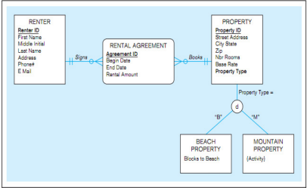ransform the diagram into a relation. In addition, verify that the resulting addition, verify that the resulting

**8.** Transform the diagram into a relation. In

relations are in 3NF.

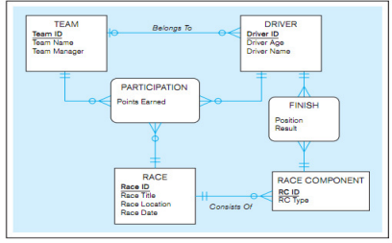

**Tut 4 Solution**

**Exercise 1**

Define each of the following terms:

a. *Determinant* The attribute on the left-hand side of the arrow in a functional dependency.

b. *Functional dependency* A constraint between two attributes or two sets of attributes.

c. *Transitive dependency* A functional dependency between two (or more) nonkey attributes.

d. *Recursive foreign key* A foreign key in a relation that references the primary key values of that same relation.

e. *Normalization* The process of decomposing relations with anomalies to produce smaller, well-structured relations.

f. *Composite key* A primary key that consists of more than one attribute.

g. *Relation* A named, two-dimensional table of data.

h. *Normal form* A state of a relation that results from applying simple rules regarding functional dependencies (or relationships between attributes) to that relation.

i. *Partial functional dependency* A functional dependency in which one or more nonkey attributes (such as Name) are functionally

dependent on part (but not all) of the primary key.

j. *Enterprise key* A primary key whose value is unique across all relations.

k. Surrogate primary key: A serial number or other system assigned primary key for a relation.

**Exercise 2.**

f well-structured relation

e anomaly

a functional dependency

j determinant

g composite key

d 1NF

h 2NF

i 3NF

c recursive foreign key

k relation

b transitive dependency

**Exercise 3.**

a. *Normal form; normalization* Normal form is a state of a particular relation regarding functional dependencies, while normalization is the process of decomposing relations with anomalies to produce smaller, well-structured relations.

b. *Candidate key; primary key* A primary key is an attribute (or combination of attributes) that uniquely identifies a row in a relation. When a relation has more than one such attribute (or combination of attributes), each is called a candidate key. The primary key is then the one chosen by users to uniquely identify the rows in the relation.

c. *Partial dependency; transitive dependency* A partial functional dependency exists when a nonkey attribute is functionally

dependent on part (but not all) of a composite primary key; a transitive dependency is a functional dependency between two or more nonkey attributes.

d. *Composite key; recursive foreign key* A composite key is a primary key that consists of more than one attribute, while a recursive foreign key is a foreign key in a relation that references the primary key values of that same relation.

e. *Determinant; candidate key* A determinant is the attribute on the left-hand side of the arrow in a functional dependency, while a candidate key uniquely identifies a row in a relation.

f. *Foreign key*; *primary key* A primary key uniquely identifies each row in a relation, while a foreign key is a primary key in another table. g. Enterprise key; surrogate primary key *An enterprise key is a primary key whose value is unique across all relations in the whole database and is likely to hold no business meaning. A surrogate primary key is a primary key whose value is a serial number or other system assigned value and is unique to the relation.*

**Exercise 4.**

3NF relations for Millennium College are:

OBJECT(OID,Object_Type)

INSTRUCTOR (OID, Instructor_Name, Instructor_Location)

COURSE (OID, Course_No, Course_Title, *Instuctor_Name*)

STUDENT (OID, Student_No, Student_Name, Major)

OUTCOME (OID, *Student_No*, *Course_No*, Grade)

**Exercise 5.**

a. Shipment Manifest

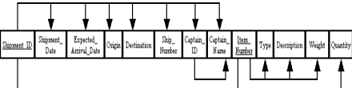

3rd Norm:

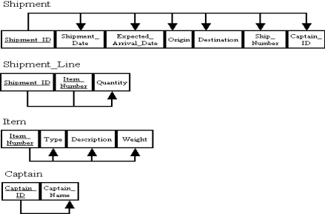

EER Diagram:

b. License Finement



**Exercise 6.**

Dependency Diagram

3rd Norm:



EER:



**Exercise 7. See Tut 5 Solution**

**Exercise 8.**

Team (**TeamID,** TeamName, Team Manager) Participation (**RaceID, TeamID, DriverID,** PointsEarned) Driver(**Driver_ID**,DriverAge,DriverName, TeamID) Race (**RaceID,** RaceTittle, RaceLocation, RaceDate) Finish(**DriverID, RC_ID,** Position,Result)

RaceComponent(**RC_ID,** RCType, Race_ID)